# Exercises: Introduction to Entity Framework

This document defines the **exercise assignments** for the ["Databases Advanced – EF Core" course @ Software University](https://softuni.bg/trainings/1741/databases-advanced-entity-framework-october-2017).

## Import the SoftUni Database

Import the SoftUni database into SQL Management Studio by **executing** the provided **.sql** script.

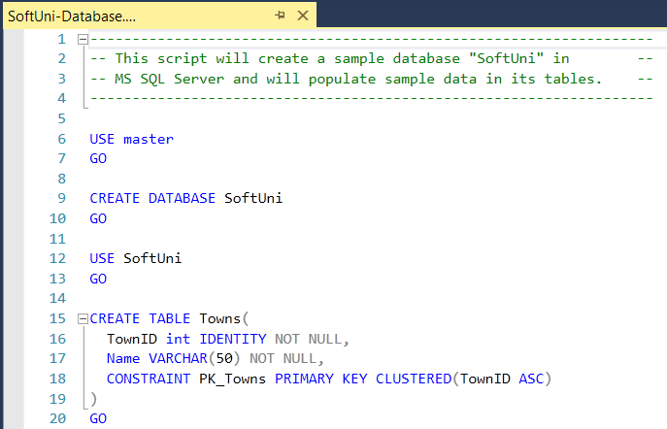

## Database First

Model the existing database by using Database First.

First create a new empty **.Net Core** **ConsoleApplication** and after it is created open the **Package Manager Console**:

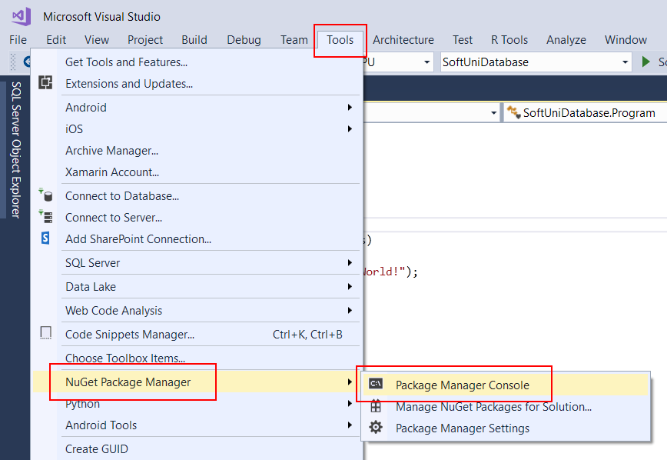

It will look something like this:

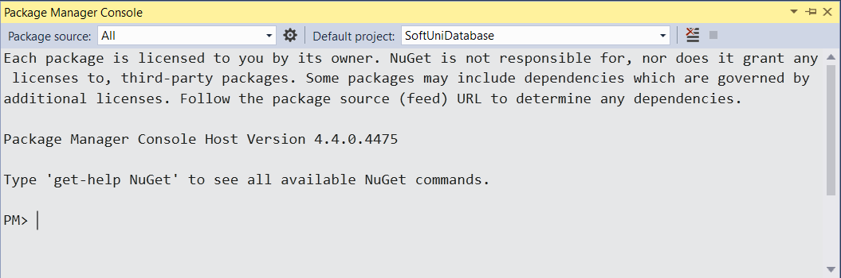

Use it to run the following commands **one by one**:

|  |
| --- |
| Install-Package Microsoft.EntityFrameworkCore.Tools –Version 2.0.0  Install-Package Microsoft.EntityFrameworkCore.SqlServer –Version 2.0.0  Install-Package Microsoft.EntityFrameworkCore.SqlServer.Design –Version 2.0.0 |

These are the **packages** you will need, in order to **scaffold** our **SoftUniContext** from the **SoftUni** **database**.

Next, we must **execute** the **command** to **scaffold** our **context** **class**. It will consist of 4 things:

* First, the name of the command:

|  |
| --- |
| Scaffold-DbContext |

* Second, the connection we will be using (our connection string):

|  |
| --- |
| -Connection "Server=<ServerName>;Database=<DatabaseName>;Integrated Security=True;" |

For **ServerName**, use the name of your local MS SQL Server instance or ".".

For **DatabaseName**, use the name of the database you want to use, in this case – **SoftUni**.

* Third, we need to declare our service provider, we’ll be using **Microsoft.EntityFrameworkCore.SqlServer**:

|  |
| --- |
| -Provider Microsoft.EntityFrameworkCore.SqlServer |

* And the fourth thing we’ll do, is to give it a directory where all of our models will go (e.g. **Models**):

|  |
| --- |
| -OutputDir Data/Models |

Our final command will look like this:

|  |
| --- |
| Scaffold-DbContext -Connection "Server=.;Database=SoftUni;Integrated Security=True;" -Provider Microsoft.EntityFrameworkCore.SqlServer -OutputDir Data/Models |

Execute the **whole command** on a **single line**

Entity Framework Core has successfully **mapped the database schema to C# classes**. However, it isn't good enough with names – all classes have been pluralized. Use the **Solution Explorer** in Visual Studio to move the **SoftUniContext** class out of **Models** intothe **Data** folder and rename all of our classes properly. Use **right click → Rename** or the **F2** shortcut and press **OK** on this **pop** **up** **window** after each class:

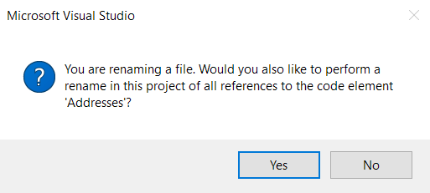

This way Visual Studio will also **rename** the **classes** **everywhere** they’re used.

The final result should look like this:

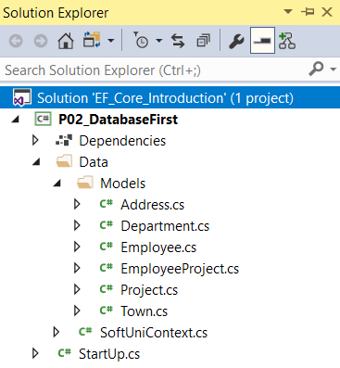

Don’t forget to fix the **SoftUniContext’s** namespace after moving it and add a reference to the **Models** namespace:

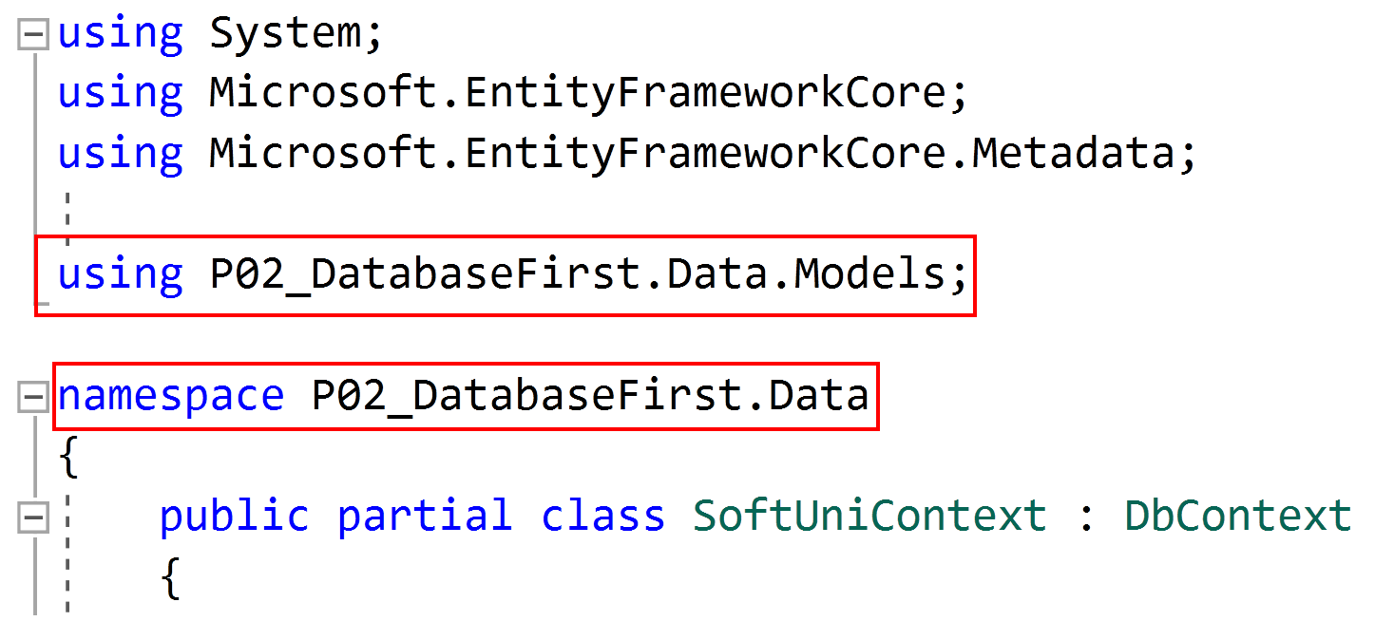

**Make** **sure** that your namespaces are **exactly** the same as these:

|  |
| --- |
| P02_DatabaseFirst  P02_DatabaseFirst.Data  P02_DatabaseFirst.Data.Models |

To be able to test our models, we need to add this **constructor** to our **SoftUniContext** class:

|  |
| --- |
| public SoftUniContext(DbContextOptions options)  :base(options) { } |

Finally, we want to clean up the packages we won’t be using anymore from the package manager GUI or by running these commands:

|  |
| --- |
| Uninstall-Package Microsoft.EntityFrameworkCore.Tools -RemoveDependencies  Uninstall-Package Microsoft.EntityFrameworkCore.SqlServer.Design -RemoveDependencies |

## Employees Full Information

Now we can use the **SoftUniContext** to extract data from our database. Your first task is to extract **all employees** andprint their **first**, **last** and **middle** name, their **job** **title** and **salary**, rounded to **2** **symbols** after the decimal separator, all of those separated with a space. Order them by **employee** **id**.

|  |
| --- |
| Output |
| Guy Gilbert R Production Technician 12500.00 |
| Kevin Brown F Marketing Assistant 13500.00 |
| … |

## Employees with Salary Over 50 000

Your task is to extract **all employees** with **salary** over **50000**. Return **only the** **first names** of those employees, ordered **alphabetically**.

|  |
| --- |
| Output |
| Brian |
| Dylan |
| … |

### Hints

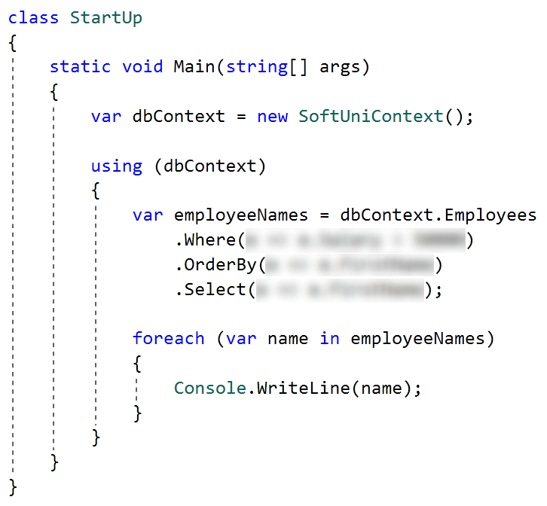

Use **Express** **Profiler** and check if the query Entity Framework Core sent is correct (there is only one query, but there may be more that are performed by EF for checks).

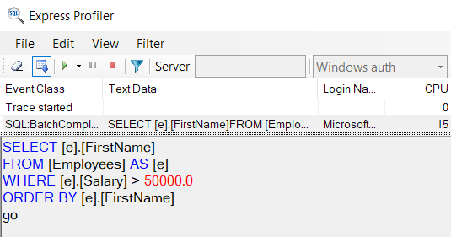

## Employees from Research and Development

Extract all employees from the **Research and Development** department. Order them by **salary** (in ascending order), then by **first name** (in descending order). Print only their **first name**, **last name**, **department name** and **salary** in the format shown below:

|  |
| --- |
| Output |
| Gigi Matthew from Research and Development - $40900.00 |
| Diane Margheim from Research and Development - $40900.00 |
| … |

### Hints

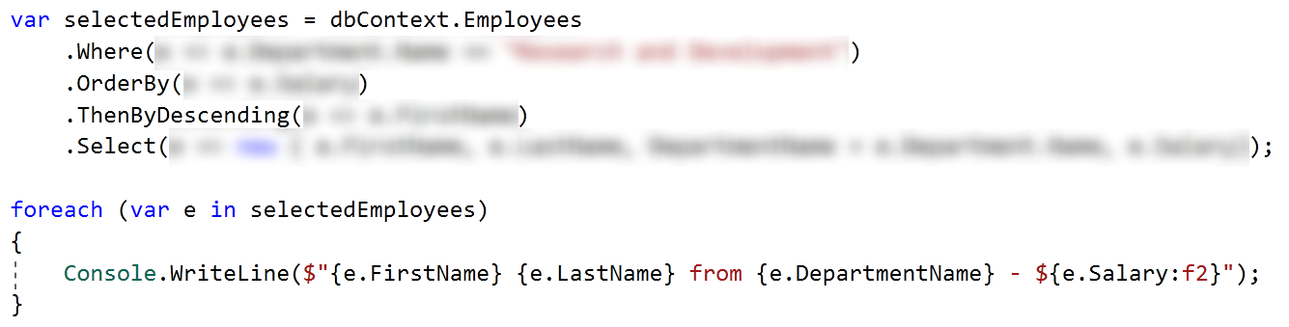

Use Express Profiler and check if the made query by Entity Framework is correct (there is only one query).

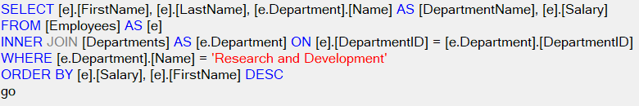

## Adding a New Address and Updating Employee

Create a new address with **text** "**Vitoshka 15**" and **TownId** **4**. Set that address to the employee with last name "**Nakov**".

Then order by **descending** all the employees by their **Address’** **Id**, take **10** rows and from them, take the **AddressText**. Print the results each on a new line:

|  |
| --- |
| Output |
| Vitoshka 15 |
| 163 Nishava Str, ent A, apt. 1 |
| … |

After this **restore** your **database** for the tasks ahead!

### Hints

Create the address and find the employee with last name equal to "Nakov" in order to assign the address to him.

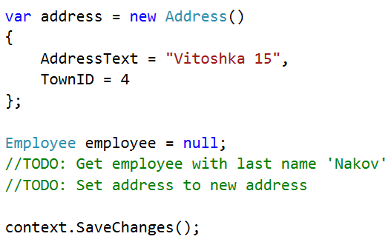

## Employees and Projects

Find the first **30** employees who have **projects** started in the period **2001 - 2003** (inclusive). Print each employee's **first name**, **last name, manager’s first name** and **last name.** Then print **all** of their **projects** in the format "--<**ProjectName**> - <**StartDate**> - <**EndDate**>", each on a **new** **row**. If a project has no end date, print "**not finished**" instead.

Here is the format:

|  |
| --- |
| Output |
| Guy Gilbert – Manager: Jo Brown |
| --Half-Finger Gloves - 6/1/2002 12:00:00 AM - 6/1/2003 12:00:00 AM |
| --Racing Socks - 11/22/2005 12:00:00 AM - not finished |
| … |

### Constraints

Use date format: "M/d/yyyy h:mm:ss tt".

## Addresses by Town

Find all addresses, **ordered** by the **number of employees** who live there (**descending**), then by **town name** (**ascending**), and finally by **address** **text** (**ascending**). Take only the **first 10 addresses**. For each address print it in the format "<**AddressText**>, <**TownName**> - <**EmployeeCount**> employees":

|  |
| --- |
| Output |
| 163 Nishava Str, ent A, apt. 1, Sofia - 3 employees |
| 7726 Driftwood Drive, Monroe - 2 employees |
| … |

## Employee 147

Get the **employee with id 147.** Print only his/her **first name**, **last name**, **job title** and **projects** (print only their names). The projects should be **ordered** **by** **name** (**ascending**). Format of the output:

|  |
| --- |
| Output |
| Linda Randall - Production Technician |
| HL Touring Handlebars |
| … |

## Departments with More Than 5 Employees

Find **all departments** with more than **5 employees**. Order them by **employee count** (**ascending**), then by **department** **name** (**alphabetically**).   
For each department, print the **department name** and the **manager’s first** and **last name** on the **first row**. Then print the **first** **name**, the **last** **name** and the **job** **title** of every **employee** on a new row. Then, print **10 dashes** before the next department ("**----------**").   
Order the employees by **first** **name** (**ascending**), then by **last** **name** (**ascending**). Format of the output:

|  |
| --- |
| Output |
| Engineering – Terri Duffy |
| Gail Erickson - Design Engineer |
| Jossef Goldberg - Design Engineer |
| … |

## Find Latest 10 Projects

Write a program that prints information about the **last 10 started projects**. **Sort** **them by name** lexicographically and print **their name, description and start date**, each on a new row. Format of the output:

|  |
| --- |
| Output |
| All-Purpose Bike Stand  Research, design and development of All-Purpose Bike Stand. Perfect all-purpose bike stand for working on your bike at home. Quick-adjusting clamps and steel construction.  9/1/2005 12:00:00 AM |
| … |

### Constraints

Use date format: "M/d/yyyy h:mm:ss tt".

## Increase Salaries

Write a program that increase salaries of all employees that are in the **Engineering**, **Tool Design**, **Marketing** or **Information Services** department by **12%**. Then **print first name, last name and salary** (2 symbols after the decimal separator)for those employees whose salary was increased. Order them by **first** **name** (**ascending**), then by **last** **name** (**ascending**). Format of the output:

|  |
| --- |
| Output |
| Ashvini Sharma ($36400.00) |
| Dan Bacon ($30688.00) |
| … |

## Find Employees by First Name Starting With "Sa"

Write a program that finds all employees whose first name starts with "**Sa**". Print their **first**, **last** **name**, their **job** **title** and **salary** in the format given in the example below. Order them by **first** **name**, then by **last** **name** (**ascending**).

*Note: You have to solve **previous** task in order to display proper results.

|  |
| --- |
| Output |
| Sairaj Uddin - Scheduling Assistant - ($16000.00) |
| Samantha Smith - Production Technician - ($14000.00) |
| … |

## Delete Project by Id

Let's **delete** the project with id **2**. Then, take 10 projects and print their names on the console, each on a new line. Remember to restore your database after this task.

|  |
| --- |
| Output |
| Classic Vest |
| Full-Finger Gloves |
| … |

### Hints

If we try to delete the project directly:

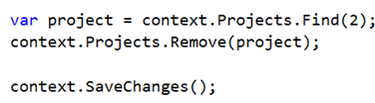

This happens:

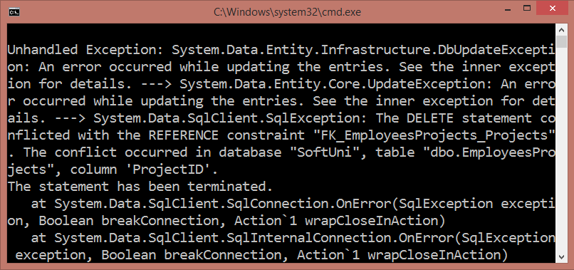

The project is **referenced** by the junction (many-to-many) table **EmployeesProjects**. Therefore we cannot safely delete it. First, we need to remove any references to that row in the **Projects** table.

This is done by removing the project from all employees who reference it.

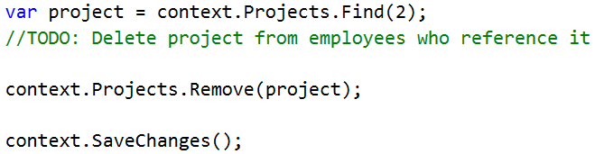

## Remove Towns

Write a program that **deletes a town** by its name, given as an input. Also, **delete all addresses** that are in those towns. Print on the console the **number** of **addresses** that were **deleted**. There will be **employees** living at those addresses, which will be a problem when trying to delete the addresses. So, start by setting the AddressID of each employee for the given address to **null**. After all of them are set to null, you may safely remove all the addresses from the context.Addresses and finally remove the **given** **town**. You should test this task **locally**, so you can see what happens for more than 1 case of deletion.

### Example

|  |  |
| --- | --- |
| Input | Output |
| Sofia | 1 address in Sofia was deleted |
| Seattle | 44 addresses in Seattle were deleted |